tive
IFG Adventure 3rd Year
Third Term – Weeks One to Three
Wearable Artz Interest

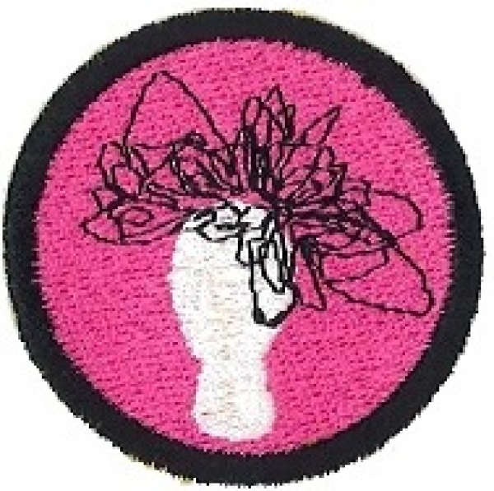
Aim: To give the girls an opportunity to create their own unique wearable art garments and accessories.
Check out the Wearable Art Website www.worldofwearableart.com for some ideas.

Objectives:
- To produce articles of wearable art using a range of materials.
- To make accessories to go with these garments.
- For the Special Awardz night at the end of this term, the girls could host a Fashion Parade modeling their wearable artz creations.
- Girls will be encouraged to use their imagination and artistic flair.

Preparation:
- Gather together items suitable for creating wearable art garments, this may need to include a visit to secondhand and op shops.
- Other items needed could be material scraps (check out cheap bins, friends and family for these), plastic rubbish bags, ribbons, buttons, paper, net, newspapers, zips, embroidery thread, lace, feathers – get the girls to come up with ideas of what they would like to have on their garments to add to this list.
- Get pins, needles, sewing machines, threads, scissors, tape measures etc.
- You may like to get some Library books on this subject to give the girls some ideas.

SetUp:
Usual fall in, roll call etc.

Devotions:
The following are some ideas for devotions:
Dorcas also known as Tabetha Acts 9 : 36-43
Joseph and his coat of many colours

Teaching Sessions:
What is wearable art?
Wearable art, also known as Artwear or "art to wear", refers to individually designed pieces of (usually) hand-made clothing or jewelry created as fine or expressive art.
Wearable art can be made from a variety of materials; it is only limited by one’s imagination.

During this three week programme encourage the girls to explore different fabrics, both fibre and non-fibre to create their wearable art garments and accessories.
Items of clothing they may wish to make include:
- A dress
- Tops
- Skirts
- Jeans

Accessories could include:
- Hats
- Bags
- Shoes
- Jewellery

The girls could work individually or in pairs where they can design their garment/accessories then work out what materials they will use to make the items. If working in pairs, it would be good for each of them to be creating an article so they both have something at the end of the three week programme and for the fashion show should you decide to hold one.

Some ideas include:
Using an old handbag the girls can transform this by adding buttons of different sizes and colours or anything else of a decorative nature to change the look of the old handbag.

Redesigning a dress – this could be one purchased from an Op shop, the girls could add some new features using material scraps, ribbons, lace, buttons etc.

Or, they could make an outfit using plastic bags this can be quite colourful using different coloured plastic bags.

Give a pair of Jeans the Grunge look:
Girls will pay a lot of money for the right look to their jeans. Here is an easy way to get the grunge look without breaking the bank.

Equipment:
- Pair of jeans
- Bleach
- Gloves (plastic)
- A kitchen grater
- Large rubbish bag
- Duct tape
- Water

How to make:
- Cut open the rubbish bag and tape it down on a flat surface.
- Place the jeans on the rubbish bag and make some dots and slashes with the bleach. Wait the allotted time and rinse the jeans off.
- Lay the jeans flat on the rubbish bag again and put on the glove. Use the vegetable grater and grate the jeans going from the waist down. This takes a bit of time, use the roughest part of the grater.
- When you start to have patches of pulled fabric you can stop grating.
- Allow the jeans to hand dry for 24 hours.
Here is something a little different (below) it is made out of recycled plastic plant tags and staples.
Ensure if using staples that there are no sharp ends to dig into the model.
This is the view from the back showing the shoulder straps, and the front is all just layered with plant tags.
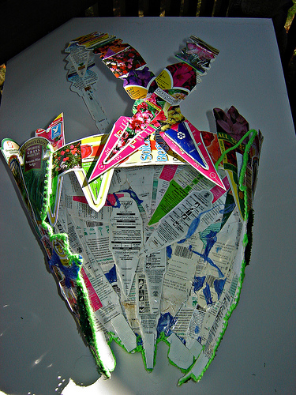
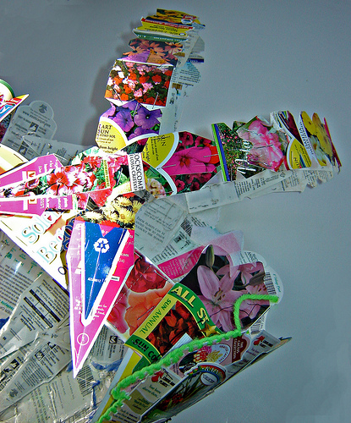

Jandals or Thongs make a good base to create shoes from or just generally decorating them up to make them look “classy”.
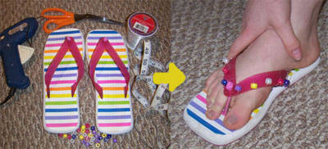

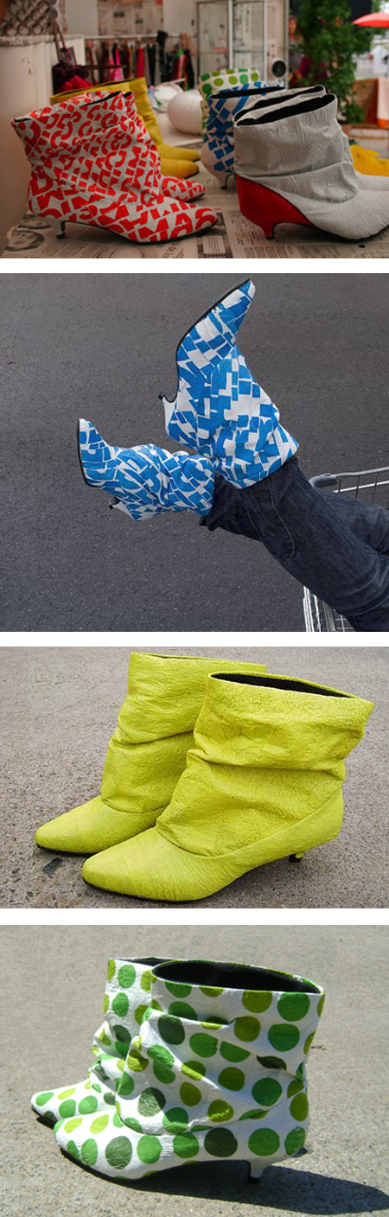
Second hand boots from the Op Shop can be transformed into these funky looking creations with a little bit of paint and ingenuity. The girls could add some buttons or other decorations to these as well.
Hats:
Here is an idea for a hat made from an old tee shirt, with two different trims and a fabric flower being added to it.
Another idea below using the crown of an old hat and adding some colour in the form of handmade flowers from scrapes of material.
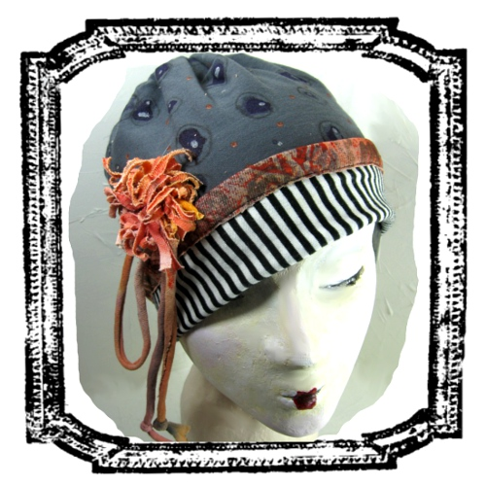
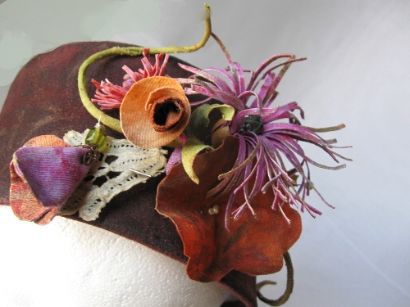

Designing a sweatshirt or t-shirt is fairly easy.
Choose colors and themes of your choice, from different fabrics.
Designs can be appliqué or painted on with fabric paints.

Instructions

Things You'll Need:
- Sweatshirt or t-shirt, any colou
- Iron on fuse a bond
- Fabric, about 1/4 to 1/2 of a metre
- Scissors
- Cardboard
- Fabric paints to match your theme
- Iron

- Wash and dry the sweatshirt or t-shirt. You don't need to use soap when washing. Iron the garments.
- Take the fabric piece and bond with fuse a bond according to instructions.
- Take scissors and cut around fabric design, cutting in and out to make it look intricate. After cutting, you peel the backing off.
- Place the design on your garment where you want it. It can be centered or asymmetric. Then press down and hold with heated iron.
- Place cardboard in between garment layers. Take fabric paints, shake and squeeze gently to outline design. You can also paint within the fabric design or pattern. Follow the directions on the bottle.

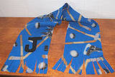
Making a scarf to go with your creation is simple:
Materials Needed:
- ¼ metre of fleece
- Masking Tape
- Scissors
Instructions:
Trim your piece of fleece to measure approximately 22cm x 130cm. Depending on the size of the person the scarf is for, you can make the scarf shorter than 130cm. This is sometimes easier using a straight edge ruler and rotary cutter if you have one.
Along one of the 22cm ends, measure up about 10cm from the edge and mark this line with a piece of masking tape running the whole 10cm width of the fabric. Cut slits in the fabric from the end up to the piece of tape about every inch so you end up with 10cm long fringe. Repeat this on the other end. Carefully remove the masking tape.
You can leave the scarf like this or embellish it as desired. You can try cutting your initials out of contrasting pieces of fleece and glue them near the fringe ends; or you can write your entire name using dimensional fabric paint. How about embellishing the entire scarf with a variety of buttons or by simply gluing small pom-poms to the ends of the fringe? Use your imagination to make the scarf special.

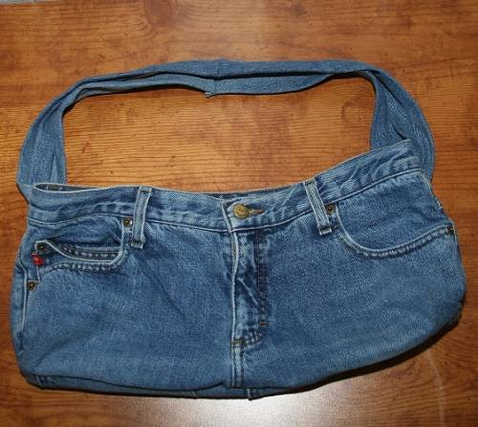
Tote bag made from an old pair of jeans:
Materials Needed:
- Pair of Jeans
- Straight pins
- Needle and thread
- Scissors

Instructions:
- Lay the jeans flat on your work surface and cut off each leg.
- From one of the legs, cut 2 strips about 10cm x 60cm
- Turn the jeans inside out and pin together each opening you just cut.
- Leaving about a 2cm seam allowance stitch the openings closed starting on one side, stitching across the crotch area, and then stitching across the other opening. Turn your new blue jean tote bag right side out. Iron if desired.
- Sew the two 10cm x 60cm strips together, using a 2cm seam allowance, so you have a strip that is approximately 10cm x 120cm
- Fold the strip in half lengthwise, right sides together. Line up the long edges and sew the entire length using about 2cm seam allowance. To form a long tube.
- Turn this tube right side out. Iron if desired. This will be your strap.
- Slip one end of your strap into the belt loop on one side of the jeans; thread that same end through the belt loop on the opposite side of the jeans. Tie or sew the two ends together.
- The strap is now ready and the bag can be embellished if desired.

These are just a few ideas; there are many more on different websites.

At the end of the each weekly session:

Closing Prayer

Notices

Home Time

